PERFORMANCE MEASUREMENT AND MODELING OF COMPONENT APPLICATIONS IN A HIGH PERFORMANCE
COMPUTING ENVIRONMENT

by
NICHOLAS DALE TREBON

A THESIS
Presented to the Department of Computer
and Information Sciences
and the Graduate School of the University of Oregon
in partial fulfillment of the requirements
for the degree of
Master of Science

June 2005

“Performance Measurement and Modeling of Component Applications in a High Performance Computing Environment,” is a thesis prepared by Nicholas Dale Trebon in partial fulfillment of the requirements for the Master of Science degree in the Department of Computer and Information Sciences. This thesis has been approved and accepted by:

____________________________________________________________
Dr. Allen Malony, Chair of the Examining Committee

_______________________________________
Date

Committee in Charge: Dr. Allen Malony, Chair
Dr. Jaideep Ray
Dr. Sameer Shende

Accepted by:

____________________________________________________________
Dean of the Graduate School

An Abstract of the Thesis of
Nicholas Dale Trebon for the degree of Master of Science
in the Department of Computer and Information Sciences to be taken June 2005
Title: PERFORMANCE MEASUREMENT AND MODELING OF COMPONENT APPLICATIONS IN A HIGH PERFORMANCE COMPUTING ENVIRONMENT

Approved: __________________________________________
Dr. Allen Malony

A parallel component environment places constraints on performance measurement and modeling. For instance, it must be possible to observe component operation without access to the source code. Furthermore, applications that are composed dynamically at run time require reusable performance interfaces for component interface monitoring. This thesis describes a non-intrusive, coarse-grained performance measurement framework that allows the user to gather performance data through the use of proxies that conform to these constraints. From this data, performance models for an individual

component can be generated, and a performance model for the entire application can be synthesized. A validation framework is described, in which simple components with
known performance models are used to validate the measurement and modeling methodologies included in the framework. Finally, a case study involving the measurement and modeling of a real scientific simulation code is also presented.

CURRICULUM VITAE
NAME OF AUTHOR: Nicholas Dale Trebon
PLACE OF BIRTH: Eugene, Oregon
DATE OF BIRTH: April 27, 1980

GRADUATE AND UNDERGRADUATE SCHOOLS ATTENDED:
University of Oregon

DEGREES AWARDED:
Master of Science in Computer and Information Sciences, 2005, University of
Oregon
Bachelor of Science in Computer and Information Sciences and Mathematics,
2002, University of Oregon

AREAS OF SPECIAL INTEREST
Performance measurement
High performance computing

PROFESSIONAL EXPERIENCE
Graduate Research Assistant, Department of Computer and Information Sciences,
University of Oregon, Eugene, 2003-2005
Intern, Sandia National Laboratories, Livermore, CA, 6//2003 – 12/2003 and
6/2004 – 9/2004

PUBLICATIONS:
A. Malony, S. Shende, N. Trebon, J. Ray, R. Armstrong, C. Rasmussen and M. Sottile,
“Performance Technology for Parallel and Distributed Component Software, “ Concurrency and Computation: Practice and Experience, Vol. 17, Issue 2-4, pp. 117-141, John Wiley & Sons, Ltd., Feb – Apr, 2005.

N. Trebon, A. Morris, J. Ray, S. Shende and A. Malony, “Performance Modeling of
Component Assemblies with TAU,” accepted for publication to Proceedings of the Workshop on Component Models and Frameworks in High Performance Computing (CompFrame 2005).

J. Ray, N. Trebon, S. Shende, R. C. Armstrong and A. Malony, “Performance
Measurement and Modeling of Component Applications in a High Performance Computing Environment: A Case Study,” Proceedings of the 18th International Parallel and Distributed Processing Symposium (IPDPS 2004), IEEE Computer Society.

N. Trebon, J. Ray, S. Shende, R. C. Armstrong and A. Malony, “An Approximate
Method for Optimizing HPC Component Applications in the Presence of Multiple Component Implementations,” Technical Report SAND2003-8760C, Sandia National Laboratories, Livermore, CA, December 2003.

A. D. Malony, S. Shende, R. Bell, K. Li, L. Li and N. Trebon, “Advances in the TAU
Performance System,” Chapter, “Performance Analysis and Grid Computing,” (Eds. V. Getov, M. Gerndt, A. Hoisie, A. Malony and B. Miller), Kluwer, Norwell, MA, pp. 129 – 144, 2003.

ACKNOWLEDGEMENTS
I wish to express sincere appreciation to my committee chair and advisor, Dr. Allen Malony, whose guidance and leadership were instrumental in my success as a graduate student. In addition, I would like to offer special thanks to Dr Sameer Shende and Dr. Jaideep Ray for serving as mentors to me at the University of Oregon and Sandia National Laboratories. Their unwavering support and kindness has proven invaluable.

TABLE OF CONTENTS
Section | Page
I. INTRODUCTION……...………………………...…………………… | 1
II. LITERATURE SURVEY……………………...……………………... | 5
Software Component Models………...……………………………... | 5
Component Measurement Frameworks…...………………………… | 6
Runtime Optimizations……………………...………………………. | 7
CCA Performance Measurement and Modeling……………...…….. | 8
III. THE COMMON COMPONENT ARCHITECTURE………………... | 10
IV. PERFORMANCE MEASUREMENT FRAMEWORK…………….. | 13
Proxy Components..……………………………………………….. | 15
Measurement Component……..…………………………………… | 17
Manager Component..……………………………………………... | 18
V. SELECTION OF THE OPTIMAL COMPONENT  IMPLEMENTATION……...……………………………………… | 20
Pruning Algorithm……..…………………………………………... | 22
Example………………..…………………………………………... | 24
Selecting an Optimal Core…..……………………………………... | 25
VI. VALIDATION OF THE SOFTWARE MEASUREMENT  AND OPTIMIZATION FRAMEWORK………………………….. | 27
VII. CASE STUDY………………………………………………………. | 31
Section | Page
VIII. FUTURE WORK……………………………………………………. | 41
Performance Modeling……………………………………………. | 41
Dynamic Implementation Selection………………………………. | 42
IX. CONCLUSIONS……………………………………………………. | 43
WORKS CITED…………………………………………………………… | 45

LIST OF FIGURES
Figure | Page
1. A Simple CCA Application Wiring Diagram………………………... | 11
2. Component Instrumented by a Single Proxy......……..……………… | 16
3. Component Instrumented by Multiple Proxies……….……………… | 16
4. The Measurement Framework Using One Proxy Per Component…... | 19
5. The Measurement Framework Using One Proxy Per Port…………... | 19
6. A Simple Call-Graph Example………………...…………………….. | 24
7. Example Code for Implementing a Component Performance  Model as a Family Member………………………………………... | 25
8. Simple Component Application Diagram…………………………… | 27
9. The Component Wiring Diagram for the Validation Example……… | 28
10. The Performance Models for both Implementations of  Component A are Plotted………………………….……………… | 28
11. The Performance Models for both Implementations of  Component B are Plotted………………………………………….. | 29
12. The Call-Graph Produced by the Component Applciation  Pictured in Figure 7………………………………………………. | 30
13. Simplified Snapshot of Simulation Components……………………. | 31
14. Execution Time for StatesConstructor……………………………… | 32
15. Average Execution Time for StatesConstructor as a Function  of Array Size……………………………………………………… | 33
Figure | Page
16. Average Execution Time for Godunov Flux as a Function  of Array Size……………………………………………………….. | 33
17. Average Execution Time for EFM Flux as a Function  of Array Size……………………………………………………….. | 33
18. Message Passing Times for Different Levels of the Grid Hierarchy… | 35
19. The Component Call-Graph for the Shock Hydro Simulation……….. | 37
20. The Call-Graph after Pruning with 10% Thresholds…………………. | 38
21. The Call-Graph after Pruning with 5% Thresholds………..…………. | 38
22. The Call-Graph after Pruning with 20% Thresholds…………………. | 39

LIST OF TABLES
Table | Page
1. The Inclusive and Exclusive Times (in Milliseconds) for each of the  Instrumented Routines……………………………………………… | 36

I. Introduction

Scientific computing is commonly performed in high performance environments in order to take advantage of parallelism to solve data-intensive problems. The application performance, in this context, is primarily influenced by two aspects: the (effective) processor speeds of the individual CPUs and the inter-processor communication time. Optimizing the performance on an individual CPU is often achieved through improving data locality. In distributed memory machines (MPPs and SMP clusters), inter-processor communication is frequently achieved through message passing and often determines the scalability and load balancing of the application. Algorithmic solutions, such as overlapping communication with computation and minimizing global reductions and barriers, are often employed to reduce these costs.

Performance measurement is typically realized through two techniques: high precision timers and hardware counters. Timers enable a user to measure the execution time of a section of code. Hardware counters track the behavior of certain hardware aspects, such as cache misses. Both of these techniques provide the application developer with insight into how the program interacts on a given machine. In a parallel environment, publicly available tools track the communication performance via metrics such as the size, frequency, source, destination and time spent exchanging messages between processors [1 – 3]. As a result of the measured data, it is possible to generate a performance model for the application that represents the estimated performance for a particular selection of problem and platform-specific parameters. Traditionally, performance measurement and modeling are generally used in an analysis-and-optimization phase, for example, when porting a stable code base to a new architecture. Performance models are also used as a predictive tool, for instance, in determining scalability [4, 5].

There has been a recent push in the scientific community to define a component-based software model in High Performance Computing (HPC) environments. This push is a direct result of the growing complexity of scientific simulation code and the desire to increase interdisciplinary collaboration. This interest led to the formation of the Common Component Architecture (CCA) Forum [6], a group of researchers affiliated with various academic institutions and national labs. The CCA Forum proposed the Common Component Architecture [7], which is a high performance computing component model.

Component-based applications introduce several interesting challenges with respect to performance measurement and modeling. First, the performance of a component application is comprised of the performance of the components and the performance of the interaction between the components. Additionally, there may exist multiple implementations of a given component (i.e., components that provide the same functionality but implement a different algorithm or use a different internal data structure). An arbitrary selection of implementations may result in a correct but sub-optimal component assembly. As a result, performance measurement and modeling in a component environment must provide a way to analyze the performance of a given component in the context of a complete component assembly. In addition, in contrast to traditional monolithic codes, direct instrumentation of the source code may not be possible in a component environment. The component user will frequently not be the author of the component and may not have access to the source code. These additional constraints highlight the need for a non-intrusive, coarse-grained measurement framework that can measure an application at the component-level.

This thesis describes a non-intrusive, coarse-grained performance measurement framework that allows the user to instrument a high performance component application through the use of proxies. From the measured data, performance models for an individual component can be generated and a performance model for the entire application can be synthesized. In addition, this thesis presents an approach to determine an approximately optimal component configuration to solve a given problem. The remainder of this thesis is organized as follows. Section II presents a literature survey that discusses the significance of several related works. Section III introduces the Common Component Architecture, which is the high performance software component model that this work is built upon. Section IV describes a proxy-based performance measurement framework that enables instrumentation of CCA applications. Section V proposes an approach to identify a nearly optimal component ensemble through the identification and optimization of core components. Section VI details a validation framework for testing the measurement and optimization framework. A case study of an application of the measurement and optimization framework to an actual scientific simulation code is presented in section VII. Areas of future work are outlined in section VIII. Conclusions are presented in section IX,

II. Literature Survey

There are numerous projects that are related to various aspects of this research. This section describes these projects and their relevance to this work.

A. Software Component Models
The three most popular commodity software component models are CORBA [8], COM/DCOM [9] and Enterprise Java Beans [10]. These models are inadequate for the needs of high performance computing because they lack support for efficient parallel communication, sufficient data abstractions (e.g., complex numbers or multi-dimensional arrays) and/or do not provide language interoperability. Because these commercial models are developed for serial applications, there is little reason for them to be concerned with the hardware details and memory hierarchy of the underlying system – aspects that are critical in HPC. Another difference is the platforms the non-HPC component models are geared towards. Their distributed applications are often executed over LANs (Local Area Networks) or WANs (Wide Area Networks); HPC applications are almost exclusively done on tightly coupled clusters of MPPs (Massively Parallel Processors) or SMPs (Symmetric Multi-Processors). As a result, inter-processor communication round-trip times and message latencies are high enough in these commercial frameworks so as to make them unsuitable for use in HPC applications.

B. Component Measurement Frameworks
Despite the shortcomings of the commercial frameworks, these models often utilize similar approaches in measuring performance. A proxy-based approach is described for the Java Beans component model [11]. For each component to be monitored, a proxy is created to intercept calls and notify a monitor component. The monitor is responsible for notifications and selecting the data to present. The principle objective of this monitoring framework is to identify hotspots or components that do not scale well in the component application.

For the CORBA component model, there is the WABASH [12, 13] tool for performance measurement. This tool is specifically designed for pre-deployment testing and monitoring of distributed CORBA systems. WABASH uses a proxy (which they refer to as an “interceptor”) to manage incoming and outgoing requests to all components that provide services (servers). WABASH also defines a manager component that is responsible for querying the interceptors for data retrieval and event management.

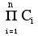
The Parallel Software Group at the Imperial College of Science in London [14, 15] works with grid-based component computing. Their performance measurement proposal is also proxy-based. The performance system is designed to select the optimal implementation of each component based on performance models and available resources. With n components, each having C_{i} implementations, there is a total of implementations to choose from. The component developer is responsible for submitting a performance model and performance characteristics of the implementation into a repository. The proxies are used to simulate the application and develop a call-path. Using the call-path created by the proxies, a recursive composite performance model can be created by examining each method-call in the call-path. To ensure an implementation-independent composite model, variables are used in place of implementation references. To evaluate the composite model, implementation performance models may be substituted for the variables, yielding an estimated execution cost. The model returning the lowest cost is selected and an execution plan is built accordingly.

C. Runtime Optimization
Two projects with similar approaches to runtime automated optimization of codes are Autopilot [16, 17] and Active Harmony [18]. Both systems require the identification of performance parameters to a monitoring and tuning infrastructure. In the case of Active Harmony, each of these parameters is perturbed during execution and the resulting effect is recorded. Active Harmony relies on a simplex algorithm to identify optimal values of the parameters, whereas Autopilot uses fuzzy logic. Both of these systems require the parameter space to be reduced by identifying “bad” regions that the system avoids. Active Harmony provides an infrastructure that enables libraries to be swapped in order to identify an optimal implementation.

D. CCA Performance Measurement and Monitoring
In CCA related optimization research [19], an extension to the CCA architecture and Ccaffeine framework is proposed in order to allow for self-managing components. These changes include modifying components to support monitoring and control capabilities and extending the framework to support rule-based management actions. The infrastructure defines two additional types of components: a component manager and a composition manager. The component manager is responsible for intra-component decisions; the composition manager administers inter-component actions. The interaction and behavior of components is expressed in high-level rules, which the system enforces.

Current research at Argonne National Laboratory is also very similar in spirit [20]. The research proposes a software infrastructure for performance monitoring, performance data management and adaptive algorithm development for parallel component PDE-based simulations. In PDE-based simulations the majority of the computation occurs in nonlinear and linear solver components. As a result, these are the two components that this software infrastructure instruments and monitors. Similar to the work described in this paper, TAU [3, 21] is used to instrument the code and performance data is stored in the PerfDMF [22] database. The goal of the infrastructure is to use the performance data and models to help in the generation of multimethod strategies (i.e., the application of several algorithms in solving a single problem) for solving large sparse linear systems of equations. This research also attempts to incorporate a quality of service aspect. Application characteristics that affect performance, such as convergence rate, parallel scalability and accuracy are stored as metadata in a persistent database. These characteristics can also be evaluated along with the performance model when a decision is made.

III. The Common Component Architecture

The Common Component Architecture is a set of standards that define a lightweight component model specifically designed for high performance computing. Prior to the CCA, the existing commodity component software models, such as CORBA [8], Microsoft’s COM/DCOM [9] and Enterprise Java Beans [10], were unsuitable for HPC for a variety of reasons. Namely, they were unequipped to handle efficient parallel communication, did not provide necessary scientific data abstractions (e.g., complex numbers and multidimensional arrays) and/or offered limited language interoperability.

The Common Component Architecture model is comprised of components that interact through well defined, standardized interfaces. Thus, application modification is achieved through altering a single component or replacing a component with an alternate that implements the same interface. This plug-and-play property is one of the driving forces behind software component models. The CCA specification is based upon the provides-uses communication model. Components provide functionality through the interfaces they export and use functionalities provided by other components. The interfaces are referred to as ports.

Components are loaded and instantiated in a framework. The CCA does not provide an actual framework, but rather, a framework specification. As a result, there are several CCA-compliant frameworks available. For the research presented in this thesis, the Ccaffeine framework [23], developed at Sandia National Laboratories, is used. The Ccaffeine framework utilizes the SCMD (Single Component Multiple Data) parallel communication model – which is simply the SPMD (Single Program Multiple Data parallel computation abstraction extended to component software. In other words, the component application is replicated on each processor, and each processor executes the application.

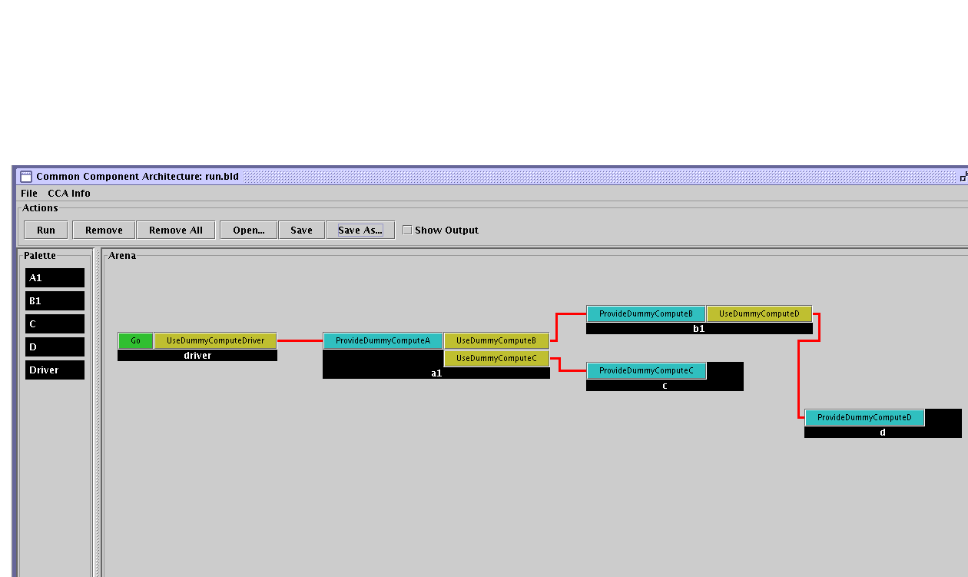
In Figure 1, a simple CCA application is presented. Instantiated components appear in the Arena portion of the diagram. Provides ports appear on the left side of a component; uses ports are located on the right. In order to connect a provides and uses port together, they must be of the same type. The driver component provides an unconnected Go port. This port’s functionality can be manipulated through the framework to start the application.
Figure 1: A simple CCA application wiring diagram.

IV. Performance Measurement Framework

The composite performance of a component application depends upon the performance of the individual components and the efficiency of their interactions. The performance of a given component is meaningless without considering the context in which it is being used. This context is defined by three factors: (1) the problem being solved, (2) the input to a component and (3) the interaction between the caller and callee components. Imagine a component that has to perform two functions on a large array. The first function accesses the array in sequential order and the second utilizes a strided access. Clearly, the performance of the component depends upon the problem being solved – which mode of access is being used. The input to the component also contributes the component’s overall performance. In the previous example, the performance for both modes of access will depend on the size of the array being processed. Increasing the amount of work a component has to perform will increase the execution time. The final contextual factor relates to the potential for mismatched data types between interacting components. In a monolithic code, the entire application is created under common assumptions and data types. This is not the case in a component environment. If a data transformation is necessary in order for two components to communicate, this conversion must be taken into account. Once a context is defined for a component, then there is an optimal choice of component implementations.

The execution of most scientific components consists of compute-intensive phases followed by inter-processor communication calls. These communication calls may include synchronization costs, such as a global reduction or barrier. This thesis makes a simplifying assumption in order to ease the construction of the performance models. Namely, it is assumed that all inter-processor communication is blocking. Thus, there is no overlap between communication and computation. This creates a clear distinction between computation phases and communication phases. As a result of this assumption, in order to generate a performance model for a component, the following is needed (for each invocation of a component’s method that is exported as a Provides Port):
- The execution time.
- The time spent in inter-processor communication. This can be determined by calculating the total inclusive time spent in all MPI calls that originate from inside the method invocation.
- The computation time, which is calculated as the difference between the two values above.
- The input parameters that affect performance. Often, these parameters will include the size of the data being operated on (e.g., size of an array) and/or a measure of some repetitive operation (e.g., the number of times a smoother may be applied in a multi-grid solution).

The first three requirements are readily available through publicly available tools, such as the Tuning and Analysis Utilities Toolkit (TAU) [3, 21]. The fourth requirement requires an understanding of the algorithm that a particular component implements.

As mentioned previously, component environments introduce new challenges in performance measurement. First, the application developer may not have access to the source code of the component, which necessitates a non-intrusive measurement framework. Second, the application developer is interested in how a component performs in a given context. From an optimization viewpoint, the application developer is interested in selecting the best set of implementations to solve a given problem, rather than improving the performance of given component. Because of this, the application developer will be interested in a coarse-grained performance of a component at the method-level. Based upon related work [11 - 15], a proxy-based measurement framework provides an ideal infrastructure that fulfills both requirements. This proxy-based system is described in detail below.

The measurement framework consists of three distinct component types that work together to measure, compile and report the performance data for a component application. The three types are: (1) the set of proxy components, (2) a measurement component and (3) a manager component. Each type is discussed in turn.

A. Proxy Components
A proxy component is a lightweight component that is logically placed in front of the component to be measured. The proxy’s primary task is to intercept each method invocation to the actual component and forward the call. By trapping the invocation, the performance of the method call may be monitored. In the CCA environment, the proxy will provide (and use) the same ports that the component-to-be-instrumented provides. The relationship between a component and a proxy is depicted in Figure 2. In this example, component C has two provides ports, a and b, which are located on the left side of the component. Uses ports are located on the right side of the component and are distinguished with an apostrophe (“’”).
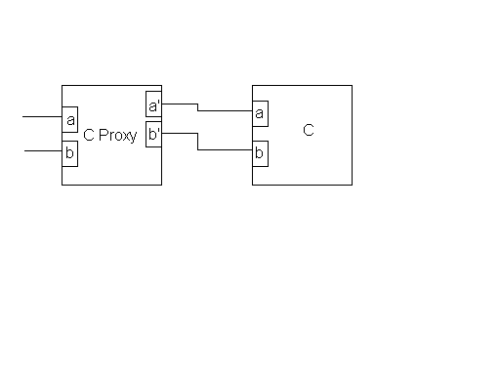
Figure 2: Component instrumented by a single proxy placed "in front" that intercepts and forwards all method calls to component C.
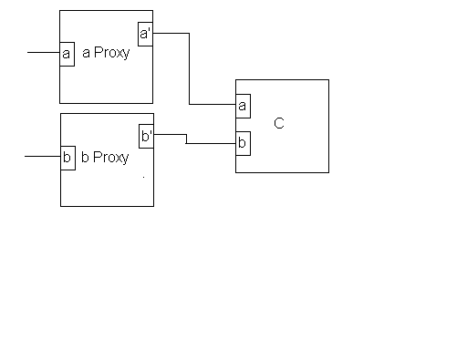
Due to the proxy’s lightweight nature and predictable construction, a tool has been developed that can automatically create proxies to instrument a CCA application. The tool is based upon the Program Database Toolkit [24], which enables analysis and processing of C++ source code. Originally, proxies were created on a component-by-component basis. If a component provided multiple ports with methods to be monitored, a proxy was created by hand that would monitor all the ports. The proxy generator, on the other hand, creates a proxy for a single port. For a component providing multiple ports, multiple proxies would be created. Figure 3 illustrates the configuration if the proxy generator is used to instrument component C from before.
Figure 3: Component instrumented by multiple proxies (i.e., one proxy per provides port).

B. Measurement Component
The second component type in the measurement infrastructure is the type that is responsible for timer creation and management, as well as interaction with the system’s hardware. This is achieved through the TAU component [25], which serves as a wrapper to the TAU measurement library [3, 21]. TAU supports both profiling (recording aggregate values of performance metrics) and tracing measurement options. The TAU component implements a MeasurementPort, which defines an interface for timing, event management, timer control, memory tracking and measurement query. The timing interface allows for timer creation, naming, starting, stopping and grouping. The event interface allows the component to track application and runtime system level atomic events. For each event, the minimum, maximum, average, standard deviation and number of occurrences are recorded. In order to interact with processor-specific hardware counters and high-performance timers, TAU relies on an external library, such as the Performance Application Programming Interface [1] or the Performance Counter Library [2]. The timer control interface allows groups of timers to be enabled or disabled at runtime. For example, TAU can be configured to instrument MPI routines through the MPI Profiling Interface. The MPI routines are automatically grouped together and the timers can be enabled or disabled via a single call. The query interface allows the program to access the performance data being measured. In addition, the TAU library dumps out summary performance profiles upon program termination.

C. Manager Component
The Manager, or Mastermind component, is responsible for collecting, storing and reporting the performance data. The Mastermind component implements a MonitorPort, which allows proxies to start and stop monitoring. For each method of a given component that is being monitored, a record is created. This record stores performance data for the given method on a per invocation basis and is updated at each successive invocation of the method. For each invocation, performance data for the computation phase and communication phase, as well as the input parameters, are recorded. Upon program termination, each record dumps their performance data to disk.

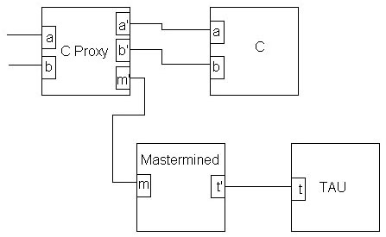
Combined, these three component types allow a component application to be non-intrusively instrumented. In an instrumented application, there is a single instance of the Mastermind and TAU components and, in most cases, multiple proxy components. Each proxy component uses the functionality provided by the Mastermind component to turn monitoring on and off for a given method. The automatic proxy generator will instrument all methods by default, but disabling monitoring is easily accomplished. The Mastermind will use the TAU component’s functionality to make the performance measurements. Examples of the relationship between the measurement framework component types are depicted in Figures 4 and 5. In both figures, component C is being instrumented. Figure 4 illustrates using a single proxy component to instrument a component with multiple provides ports. Figure 5 demonstrates the configuration using separate proxies for each provides port of component C – this is the configuration that would be constructed in conjunction with the automatic proxy generator. As seen from this example, the use of the proxy generator results in an increase of proxies to be managed by the application developer. However, proxy management is a simple task and the one-proxy-per-component methodology simplifies the complexity of the automatic proxy generator.
Figure 4: The measurement framework using one proxy per component.

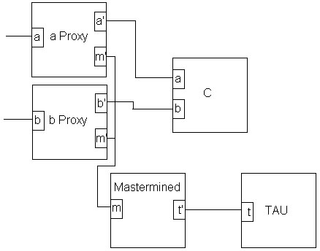
In order to ease the storage and analysis of the measured data, the Performance Data Management Framework [22] was utilized. This framework includes a database to store measurement data, which was the primary use of the framework for this study.
Figure 5: The measurement framework using one proxy per port.

V. Selection of the Optimal Component Implementation

With the ability to effectively instrument a component application and produce performance data, empirical performance models for individual components can be generated through a variety of methods, such as regression analysis. These component models can be composed together to create a performance model for the component application. This introduces the question of which component implementations will offer the best performance for a given problem? Optimizing decisions locally by simply selecting the component with the best performance characteristics may not necessarily guarantee an optimal global solution, as the individual component models do not take into account interaction between components. This interaction may include such performance costs as translating input data for mismatched data structures. An optimal solution can be realized by evaluating the global performance model for all possible realizations of the component ensemble. This section describes an approach for an approximately optimal global solution.

A typical scientific application may contain as many as 10 to 20 components. If each component has three realizations, then there are 3¹⁰ to 3²⁰ total configurations. The size of the solution space makes the brute-force approach of enumerating and evaluating all possible realizations unfeasible. However, typical scientific component applications possess solver components that are often responsible for a majority of the application’s work. Through identification and optimization of these dominant core components, an approximately optimal solution can be achieved. By eliminating “insignificant” components from the optimization phase, the solution space can be reduced to a more manageable size. After optimizing the dominant core components, a complete, near optimal application can be realized through incorporating any implementation of the insignificant components. The justification being that even a poor choice of implementation for an insignificant component will have very little effect on the application’s overall performance.

In order to identify the core components, the performance measurement framework described was extended to create a component call-graph during the execution of the application. It is important to note that a component implementation may exist in multiple places in the call-graph, since it may appear in multiple call-paths. This raises an interesting point about component implementations that appear in multiple places. First, an implementation may have an instance in the call-graph that is determined to be insignificant and another that is deemed to be significant. It is appropriate to prune off some instances of a component while leaving others behind. The justification is that insignificant instances of an implementation are still insignificant – they do not have a large impact on the application’s overall performance. More importantly, multiple instances in the component call-graph may require separate performance models, due to a change of context since the instance may be interacting with different components. One instance may require a data layout transformation, while another instance may not.

A simple, heuristic-based algorithm is employed to prune insignificant branches from the call-graph generated from the performance measurement phase. This approach is detailed in the algorithm below:

A. Pruning Algorithm
Let C_{J} represent the set of children of node J. Let T_{i}, i ∈ C_{J} be the inclusive time of child i of node J. Let J have N_{J} children, i.e., the order of the finite set C_{J} is N_{J}. When examining the children of a given node, there are two cases that result in a prune:

- The total inclusive time of the children is insignificant compared the
inclusive time of node J i.e., $\sum_{i,j∈CJ}{Ti/Tj<α}$, where 0 < α < 1. Thus, the children that contribute little to the parent node’s performance may be safely eliminated from further analysis. For the experiments described in this paper, α was typically around 0.1.

- The total inclusive time of the children is a substantial fraction of node J’s
inclusive time i.e., the children contribute significantly and $\sum_{i,j∈CJ}{Ti/Tj>α}$.
In this case, the children are analyzed to identify if insignificant siblings exist. Let $\bar{T}=\sum_{\text{i,j}∈CJ}{T\text{i }\text{/N}j}$ be the average, or representative, inclusive time for the elements of C_{J}. Eliminate nodes of C_{J} where $Ti/{\bar{T}}<β$. Thus, children of J whose contributions are small relative to a representative figure are eliminated. Typically, β is chosen to be around 0.1.

In the pruning algorithm, inclusive time is used in the pruning decisions (rather than exclusive time) to avoid pruning a branch that has an insignificant root, but significant children. The call-graph must be kept connected, in order to preserve the context of interacting components. The algorithm describes two ways for components to be deemed insignificant. First, if the total contribution of the children is less than some specified threshold, all the children may be safely pruned. The second heuristic is applied if the first fails to prune the children. In this case, each child is examined separately and its contribution is compared to the average contribution of its siblings. Pruning decisions are made based on a parent or sibling’s contribution rather than to the overall application execution time because the pruner is looking for relative significance and not absolute. For example, consider a call-graph where the root node has 15 children. Imagine that all of the work is accomplished in the children and each child contributes equally (i.e., each provides 1/15 of the overall execution time). If the pruner made decisions relative to the overall execution time (using a threshold of 0.1), all 15 children would be pruned, thus leaving behind a single node tree. Instead, with the rules described above, all 15 children would be kept, as each child would be deemed significant relative to the contributions of its siblings.

B. Example
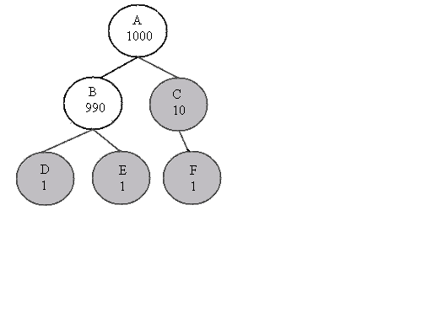
Consider the pruning algorithm applied to the following example call graph in Figure 6. The call-graph consists of 6 nodes. Their inclusive performance contributions are indicated by the internal value in each node. For the example, threshold values of 0.1 are used for both α and β. The pruning algorithm works in a depth-first manner, beginning at node A. Children B and C do contribute significantly, relative to A’s inclusive contribution, so both children are preserved (1000 / 1000 > 0.1). Each child is then examined with respect to its sibling’s contribution. The average contribution for the two siblings is 500. Thus, with a 10% threshold, a node with a contribution less than 50 would be pruned. In this example, node C is pruned (along with its children). Because inclusive time is used, there is no worry that one of C’s children could be significant. The final step in this example is to analyze B’s children. In this case, 2/990 < 0.1, so both children are pruned. The result is a dominant core tree.
Figure 6: A simple call-graph example with pruned nodes shaded. The internal value represents the inclusive performance contribution

C. Selecting an Optimal Core
Once the core components have been identified, an approximately optimal global solution can be achieved through a brute-force search of the reduced solution space. For this step, a library was developed that enumerates each realization and evaluates the performance for each ensemble. Implementations of the same component are grouped into families (i.e., implementations that may be swapped for one another exist in the same family). In the example call-graph depicted in Figure 6, each node represents a family member. Thus, any alternate implementation of component B will exist in the same family as B. Each family member implements a method that evaluates a hard-coded performance model. In Figure 7, the example C++ source code is presented for creating a family member instance of component B (from Figure 6). The getPerfPrediction method accepts three input values. The first is a vector of values that serve as inputs to the performance model. Second, a method name is supplied that indicates which method is being called. The final input is a map where the result of the performance model evaluation is stored.
class B : public virtual modeling::AbstractFamilyMember{
public:
B(string name) : AbstractFamilyMember(name){}
int getPerfPrediction(vector<double> inputs,
string method_name,
map<string, double> & predictions){
if(method_name == “go”)
predictions[“Exec. Time”] =
array_dims[0] * array_dims[0];
return 0;
}
};
Figure 7: Example code for implementing a component performance model as a family member.

After all the family members are declared, a user can explicitly group them into families. A component ensemble is evaluated by selecting one implementation (i.e., family member) from each family. The configuration that produces the best result is returned.

VI. Validation of the Software Measurement and Optimization Framework

In order to verify the measurement and optimization phases described in the previous sections, a validation framework was developed. Using “dummy” components that implement a known performance model enables verification of both the measurement and optimization stages. These components do not actually perform any work; instead, they sleep based upon their input parameter(s). Thus, it is trivial to create a test application that performs to any specification.

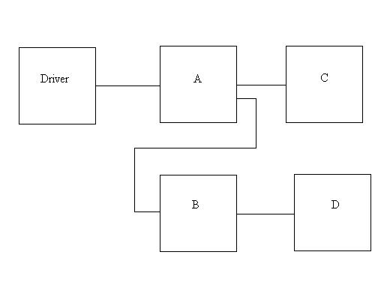
In order to test the framework, the component application depicted in Figure 8 was implemented. Components A and B each have two implementations that realize distinct performance models. Components C and D are included as examples of insignificant components. Thus, they contribute very little to the overall performance of the application. In Figure 9, the wiring diagram for the application is displayed using the first implementation of components A and B. Similar to the previous figures, uses ports are situated on the right of a component and provides ports on the left.
Figure 8: Simple component application diagram.
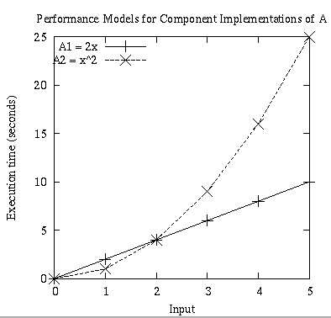
Figure 10: The performance models for both implementations of component A are plotted.
Figure 9: The component wiring diagram for the validation example.
Component A’s implementations execute the performance models y = 2x and y = x². These models are graphed in Figure 10. Component B’s implementations execute the models y = x³ and y = 2x². The models for component B are plotted in Figure 11. The models for A and B both have similar characteristics. Both components have a clear choice of which implementation offers better performance, but this choice depends upon the input. At input values x > 2, the ideal implementation is the realization executing the lower order performance model. This attribute enables the testing of the implementation selection library through modification of the inputs.
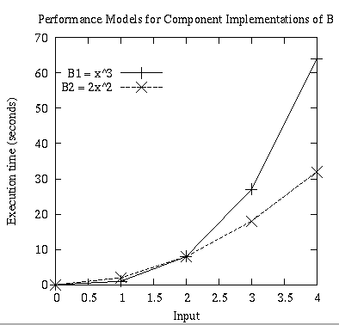
Figure 11: The performance models for both implementations of component B are plotted.
To test the measurement phase, the components were instrumented using proxies. Multiple runs using distinct ranges of input values were used in the execution of the application. The first run consisted of a set of input values of x < 2 to components A and B; the second run consisted of a set of input values x > 2; the third run consisted of a mix of input values x >0. Upon completion of the execution of the application, the performance results were analyzed. The proxies were successful in measuring the performance of the components, as the measurements matched the expected results. For each set of input values, the models were evaluated by hand and matched to the results recorded by the measurement framework.

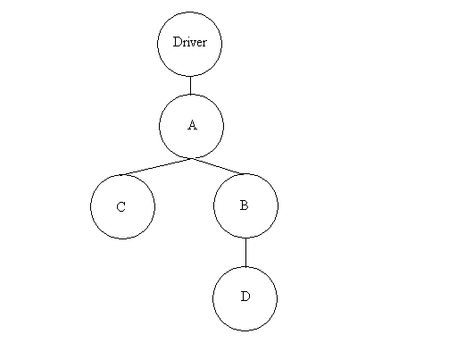
In order to test the optimization phase, the application call-graph in Figure 12 was pruned using the 10% threshold levels. As expected, the pruner identified components A and B (along with the Driver) as the core components. Conversely, C and D were removed from consideration. Using performance models generated from the measured data, the optimization library was used to identify the optimal implementations. For the experiment consisting of input values of x < 2, implementations A2 and B1 were correctly identified as the optimal choices. Implementations A1 and B2 were identified as the optimal choices for the set of input values x > 2. For the third mix, the majority of inputs were sufficiently greater than two such that A1 and B2 were the clear choices. The optimization library correctly identified this result.
Figure 12: The call-graph produced by the component application pictured in Figure 7.

VII. Case Study

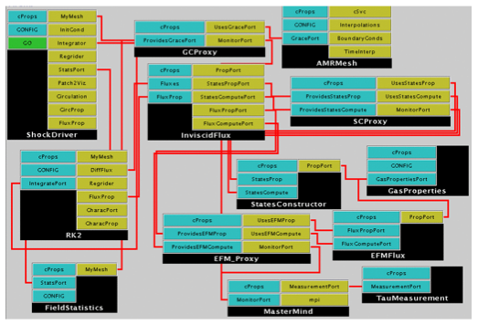
The performance measurement framework was used to instrument a component-based scientific simulation. The code simulates the interaction of a shock wave with an interface between two gases [26]. The simulation solves the Euler equations (a set of partial differential equations) using structured adaptive mesh refinement [27 - 29]. The component application is depicted in Figure 13. In order to simplify the figure, not all the components needed for execution are included. In the top left is the ShockDriver that orchestrates the simulation. The AMRMesh component is responsible for managing the patches of the adaptive mesh refinement strategy. Most of the inter-processor communication is done within this component. The StatesConstructor and EFM component are called on a patch-by-patch basis. In the figure, only two proxies are included due to space constraints, but the simulation was fully instrumented. There is a GodunovFlux component that is not shown, which can be substituted for the EFM component. One of the goals of the case study was to compare the performance between these two components. In addition, the computation time for the StatesConstructor component and the message passing costs of the AMRMesh component were analyzed.
Figure 13: Simplified snapshot of simulation components assembled for execution.

The simulation was run on three processors of a cluster of dual 2.8 Ghz Pentium Xeons with 512 KB caches. The components were compiled using –02 optimization flag for gcc version 3.2.

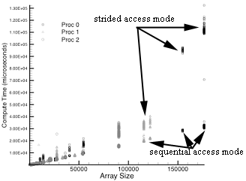
In Figure 14, the execution times for the StatesConstructor component across all three processors are plotted for a single simulation. Note that multiple invocations of the routine occur with the same array size. As the size of the input array increases, the execution times begin localizing into two groups. This is the result of the component using two modes of operation: a sequential array access mode and a strided array access mode. For the smaller, largely cache-resident arrays, the two modes perform similarly, but once the cache begins to overflow, the performance of the strided mode begins to decrease relative to the sequential mode. Note, that at the largest array sizes, the strided access costs up to four times as much as the sequential access. The behavior of the Godunov and EFM components is very similar, because both also utilize the two methods of array access.
Figure 14: Execution time for StatesConstructor. The invoked method has two modes of operation, one that access the array in a sequential fashion and the second accesses the array in a strided fashion.

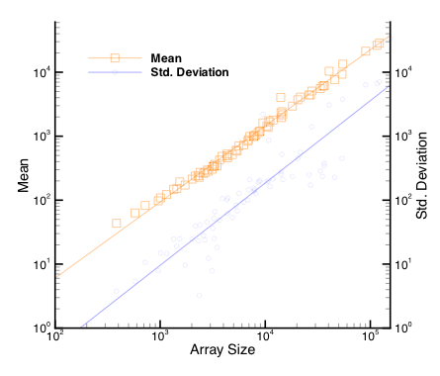
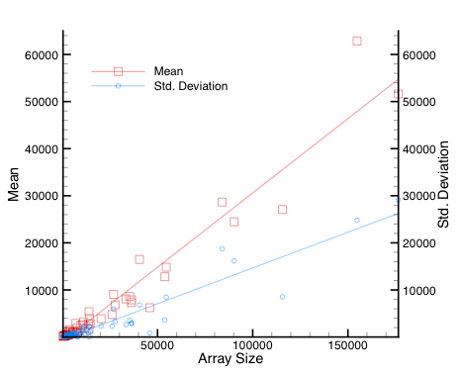
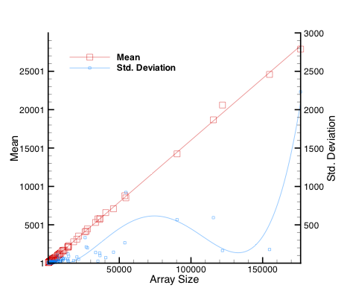
The two modes of operation of these components are invoked in an alternating fashion during the execution of the application. As a result, the execution times of the two modes are averaged to create a single performance model for each component. In Figure 15, 16 and 17, the average execution times for each array size are plotted. Also included, is the standard deviation. In all three cases, the variation increases as the array size increases. Regression analysis was used to fit a simple polynomial or power equation to the mean execution time and standard deviation for each component. These equations are also plotted in each graph. With the cache-effects averaged out, the mean execution times scale linearly with the array size.
Figure 15: Average execution time for States Constructor as a function of array size.

Figure 16: Average execution time for Godunov Flux as a function of array size.
Figure 17: Average execution times for EFM Flux as a function of array size.

If T_{States}, T_{Godunov} and T_{EFM} are the execution times (in microseconds) for the three components and Q is the input array size, the best-fit expressions plotted in each of the figures are:
T_{States} = exp(1.19 log(Q) – 3.68)
T_{Godunov} = -963 + 0.315Q
T_{EFM} = -8.13 + 0.16Q
The corresponding expressions for the standard deviations, σ, are:
σ_{States} = exp(1.29 log Q)
σ_{Godunov} = -526 + 0.152Q
σ_{EFM} = 66.7 – 0.015Q + 9.24 x 10⁻⁷ – 1.12 x 10⁻¹¹Q³ + 3.85 x 10⁻¹⁷ Q⁴

These models indicate that the Godunov component offers poorer performance than the EFM component, especially for large arrays. The variability in timings is also more severe for the Godunov component. Based on these characteristics, EFM appears to be a better a choice. However, in reality, scientists often prefer the Godunov solver because it provides greater accuracy. This is indicative of the necessity to include a quality of service aspect (i.e., accuracy, stability and/or robustness) into the performance model. As a result, the performance of a component would be relative to the size of the problem as well as the quality of the solution produced.

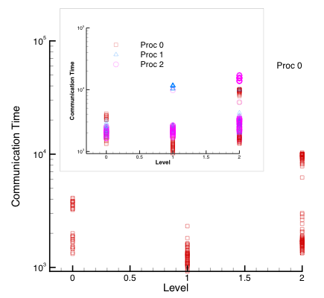
In Figure 18 the communication time spent at different levels of the grid hierarchy during each communication step is plotted. The primary graph plots the communication time for processor 0. The simulation included a load balance step, which caused a new domain decomposition. This resulted in the clustering of timings evident at levels 0 and 2. Ideally, these clusters should have collapsed to a single point; fluctuating network loads causes the substantial scatter. The inset graph includes the timings across all three processors. In comparison with the execution times displayed in Figures 15, 16 and 17, the communication times are similar. This indicates that the application, in its current context (i.e., problem being solved and accuracy desired), is unlikely to scale well. Corroborating this hypothesis is the fact that nearly a quarter of the application’s entire execution time was spent in message passing.
Figure 18: Message passing times for different levels of the grid hierarchy. The clusterings are a result of a re-grid step that resulted in a different domain decomposition. INSET: The timings across all three processors.

After analyzing the performance models by hand, the next step was to utilize the optimization library to select the optimal component applications. In Table 1, the inclusive and exclusive computation times, along with the inclusive percentage of the total execution time for each instrumented routine is presented. All values are averaged over the three processors. The exclusive time is the time spent in a routine minus the time spent in all instrumented routines called from within the routine. This table clearly illustrates that not all component contributions are equal. In fact, 10 out of the 15 total instrumented routines individually contribute less than 10% of the total execution time.
Component Name | Method Name | Excl. Time (ms) | Incl. Time (ms) | %
driver_proxy | go() | 285 | 90,785 | 96
rk2_proxy | Advance() | 6,887 | 34,411 | 36.4
ee_proxy | Regrid() | 31,607 | 32,582 | 34.5
flux_proxy | compute() | 3,118 | 22,156 | 23.4
sc_proxy | compute() | 11,131 | 11,131 | 11.8
efm_proxy | compute() | 7,549 | 7,549 | 8.0
grace_proxy | GC_Synch() | 1,956 | 3,689 | 3.9
icc_proxy | prolong() | 1,044 | 1,044 | 1.1
grace_proxy | GC_regrid_above() | 644 | 946 | 1.0
icc_proxy | restrict() | 815 | 815 | 0.9
stats_proxy | compute() | 212 | 271 | 0.3
c_proxy | compute() | 129 | 253 | 0.3
rk2_proxy | GetStableTimestep() | 5 | 157 | 0.2
cq_proxy | compute() | 86 | 150 | 0.2
bc_proxy | compute() | 38 | 38 | 0.0

Table 1: The inclusive and exclusive times (in milliseconds) for each of the instrumented routines. The percentage of inclusive time for each routine reltaive to the total execution time is also included.

In Figure 19, the call-graph generated by the measurement framework is presented. As mentioned in section III, multiple instances of the same component may exist in the call-graph if a component exists along multiple call-paths (e.g., there are five instances of the ICC component).
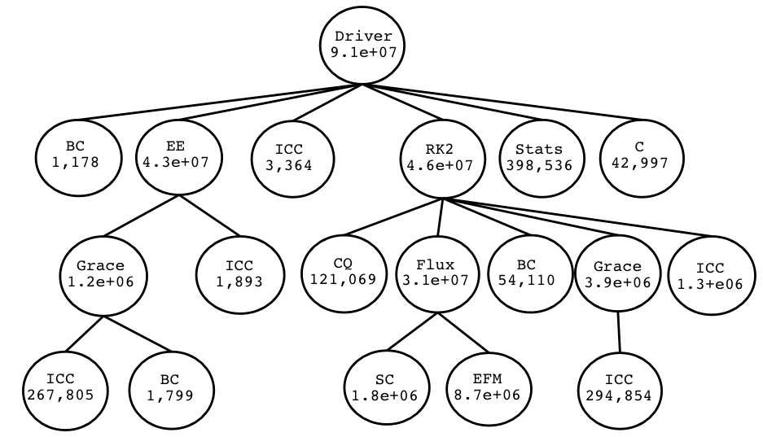
Figure 19: The component call-graph for the shock hydro simulation. Along with the component name, the inclusive computation time (in microseconds) is included in each node.
In order to identify the core components, the call-graph is first re-created by the tree pruning algorithm, which prunes branches based upon the values of the α and β thresholds. Initially, these thresholds were set to 10%. The resulting call-graph is depicted in Figure 20, with the pruned branches shaded. The original call-graph consisting of 19 nodes (12 unique component instances) is reduced to a call-graph of 8 nodes (8 unique component instances). The amount of nodes has been reduced by nearly 60%.
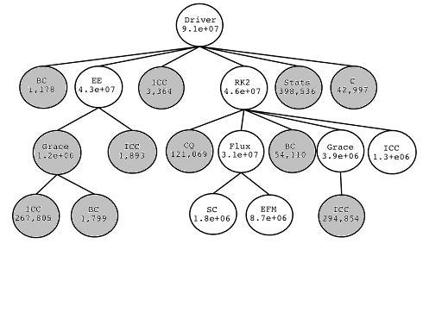
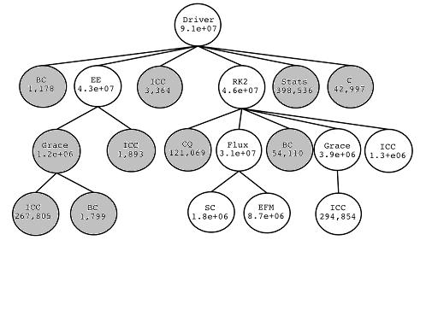
Figure 20: The call-graph after pruning with 10% thresholds.
Figure 21: The call-graph after pruning with 5% thresholds.
The call-graph was also pruned using α and β thresholds of 5% and 20%. The results are presented in Figures 21 and 22. As would be expected, by lowering both thresholds to 5%, the pruning algorithm removes fewer branches. Also, by increasing the thresholds to 20%, the pruner removes a branch that the 10% thresholds had deemed “significant”. Thus, manipulating the thresholds may result in a faster (smaller “core” call-graph), yet less accurate (lower recovery of actual inclusive time of call-graph root from the “core” call-graph). Although not included in the case study, this flexibility enables a user to conduct a sensitivity analysis (with respect to α and β), if desired.
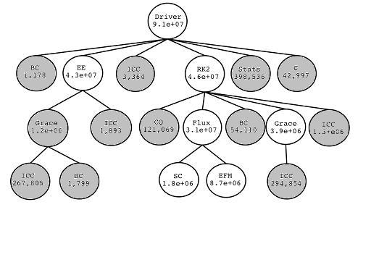
Figure 22: The call-graph after pruning with 20% thresholds.
Using the core call-graph depicted in Figure 20, the optimal set of implementations is selected using the library detailed in section III. Using the performance models for each component that were generated after the performance measurement phase, the library calculates the optimal configuration of component implementations. For the shock hydro simulation, the only choice between component implementations was between the EFM and Godunov components. The library correctly identified the EFM implementation as the “best” choice, as it resulted in the ensemble with the smallest execution time. However, as mentioned earlier, Godunov is actually the preferred choice by scientists due to its quality of service aspects, which are not included in the performance models at this time.

VIII. Future Work

There are numerous opportunities for further investigation in the measurement framework and optimization library described in this paper. Several of these areas of interest are listed below.

A. Performance Modeling
The performance models derived in this work are high-level and, as a result, are only relevant if the component application is executed on a similar cluster of machines. Any change in the system, such as modifying the cache size, will have a large affect on the coefficients in models derived in the case study. Ideally, the coefficients should be parameterized by the processor speed and cache model.

Another performance modeling aspect is how the models are represented in the implementation selection phase. Currently, the models are hand-coded in and evaluated by the library. A much more user-friendly and convenient approach would be to have the library read in the performance models from a file, as an executable expression. One possible approach would be to express the models using XML [30] or MathML [31] and have the optimization library parse the file and construct the expressions at runtime.

Finally, as mentioned several times, the performance models do not take into consideration any aspects of quality-of-service. As a result, the optimization library identified the solver with the shortest time to solution, even though it provides less accuracy. Future work would allow for these considerations to be included in the evaluation of the performance models.

B. Dynamic Implementation Selection
One of the interesting features about the Ccaffeine framework is the ability to dynamically connect components at runtime. This ability allows for the possibility of swapping a poorly performing component implementation for another on the fly. Preliminary work on an Optimizer component has begun. This component has the ability to swap one component instance for another, including inserting a proxy for the new component and updating all connections to that proxy and to the Mastermind component. Future work would include enabling the Optimizer to analyze the actual performance of current components compared to the expected performance. Any components that are not performing adequately and have an alternate implementation available, could be swapped.

IX. Conclusions

This thesis proposes a software infrastructure designed to non-intrusively measure performance in a high performance computing environment. Proxies provide a clean and simple solution to the performance measurement problem. However, in order to model the performance of a component, the context in which it is used must be taken into account. Specifically, the input parameters that affect the component’s performance must be recorded. The proxy is a logical choice to extract this information, but this does not answer the question of which parameters to extract.

In addition, a technique is described to identify a nearly optimal selection of component implementations. First, the set of core components is identified by pruning insignificant branches off of the component call-graph. Multiple implementations of a single component that exist in the reduced call-graph are grouped into families. A global performance model is synthesized and evaluated by selecting an instance from each family and evaluating its individual model and its inter-component interactions. A complete, nearly optimal solution is achieved by adding in any implementation of the insignificant components that were pruned in the first step.

In order to test the validity of the measurement and optimization framework, a verification methodology was also proposed. By implementing “dummy” components that implement a known performance model, the accuracy of the framework may be evaluated. A test application was presented in which two components each had two separate implementations. The optimal implementation, for each component, depended upon the input. Because the dummy components implemented known performance models, the results of the measurement and optimization phases were easily verified by hand.

Finally, a case study was presented in which the measurement and optimization framework was applied to a real life scientific simulation code. The framework enabled the non-intrusive instrumentation of the application. The measured performance data was used in the generation of empirical performance models, which were used in the optimization phase. The case study included a choice of two implementations, and the optimization phase correctly identified the implementation that provided the smallest execution time. However, the slower implementation is often the preferred choice by scientists because it provides better accuracy. This result indicates that a quality of service aspect (e.g., accuracy, robustness, etc.) is also important in evaluating an optimal selection.
Works Cited
[1] PAPI: Performance Application Programming Interface. http://icl.cs.utk.edu/projects/papi. Accessed May 2005.

[2] PCL – The Performance Counter Library. http://www.fz-juelich.de/zam/PCL. Accessed May 2005.

[3] A. D. Malony and S. Shende, Distributed and Parallel Systems: From Concepts to Applications. G. Kotsis and P. Kacsuk, Eds. Norwell, MA: Kluwer, 2000, pp. 37-46.

[4] D. J. Kerbyson, H. J. Alme, A. Hoisie, F. Petrini, H. J. Wasserman and M. L. Gittings, “Predictive performance and scalability modeling of a large-scale application,” in Proceedings of Supercomputing (SC2001), Denver, CO, 2001.

[5] D. J. Kerbyson, H. J. Wasserman and A. Hoisie, “Exploring advanced architectures using performance prediction,” in Innovative Architecture for Future Generation High-Performance Processors and Systems, IEEE Computer Society Press, 2002, pp 27-37.

[6] The Common Component Architecture Forum. http://www.cca-forum.org. Accessed May 2005.

[7] R. Armstrong, D. Gannon, A. Geist, K. Keahey, S. Kohn, L. McInnes, S. Parker and B. Smolinski, “Toward a common component architecture for high-performance scientific computing,” in Proc. 8th IEEE Symposium on High Performance Distributed Computing (HPDC-8), Redondo Beach, CA, August 1999.

[8] CORBA Component model webpage. http://www.omg.com. Accessed July 2002.

[9] J. Maloney, Distributed COM Application Development Using Visual C++ 6.0. Prentice Hall, 1999.

[10] R. Englander, Developing Java Beans (Java Series). O’Reilly and Associates, 1997.

[11] A. Mos and J. Murphy, “Performance monitoring of Java component-oriented distributed applications,” in IEEE 9th International Conference on Software, Telecommunications and Computer Networks (SoftCOM2001), Split, Croatia, 2001.

[12] B. Sridharan, B. Dasarathy and A. Mathur, “On building non-intrusive performance instrumentation blocks for CORBA-based distributed systems,” in 4th IEEE International Computer Performance and Dependability Symposium, Chicago, IL, March 2000.

[13] B. Sridharan, S. Mundkur and A. Mathur, “Non-intrusive testing, monitoring and control of distributed CORBA objects,” in TOOLS Europe 2000, St. Malo, France, June 2000.

[14] N. Furmento, A. Mayer, S. McGough, S. Newhose, T. Field and J. Darlington, “Optimisation of component-based applications within a Grid environment,” in Proceedings of Supercomputing (SC2001), Denver, CO, 2001.

[15] N. Furmento, A. Mayer, S. McGough, S. Newhose, T. Field and J. Darlington, “ICENI: optimization of component applications within a grid environment,” Parallel Computing, 28:1753-1772, 2002.

[16] R. L. Ribler, H. Simitci and D. A. Reed, “The Autopilot performance-directed adaptive control system,” Future Generation Computer Systems, 18:175-187, 2001.

[17] R. L. Ribler, J. S. Vetter, H. Simitci and D. A. Reed, “Autopilot: adaptive control of distributed applications,” in Proceedings of the 7th IEEE International Symposium on High Performance Distributed Computing, Chicago, IL, 1998.

[18] C. Tapus, I-H. Chung and J. K. Hollingsworth, “Active Harmony : towards automated performance tuning,” in Proceedings of Supercomputing (SC2002), Baltimore, MD, November 2002.

[19] H. Liu and M. Parashar, “Enabling self-management of component-based high-performance scientific applications,” in Proceedings of the 14th IEEE International Symposium on High Performance Distributed Computing (HPDC-14), Research Triangle Park, NC, July 2005.

[20] B. Norris and I. Veljkovic, “Performance monitoring and analysis components in adaptive PDE-based simulations,” submitted to the 24th International Symposium on Computer Performance, Modeling, Measurements and Evaluation, Juan-les-Pins, France, October 2005. Argonne National Laboratory preprint ANL/MCS-P1221-0105.

[21] TAU: Tuning and Analysis Utilities. http://www.cs.uoregon.edu/research/paracomp/tau. Accessed May 2005.

[22] K. Huck, A. Malony, R. Bell, L. Li and A. Morris, “Design and implementation of a parallel performance data management framework,” to be published in Proc. International Conference on Parallel Processing (ICPP-05), Oslo, Norway, June 2005.

[23] CCAFFEINE HOME. http://www.cca-forum.org/ccafe. Accessed May 2005.

[24] PDT: Program Database Toolkit. http://www.cs.uoregon.edu/research/paracomp/pdtoolkit. Accessed May 2005.

[25] S. Shende, A. D. Malony, C. Rasmussen and M. Sottile, “A performance interface for component-based applications,” in Proc. of International Workshop on Performance Modeling, Evaluation and Optimization of Parallel and Distributed Systems (IPDPS03), Nice, France, April 2003.

[26] R. Samtaney and J.J. Zabusky, “Circulation deposition on shock-accelerated planar and curved density stratified interfaces: Models and scaling laws,” J. Fluid Mech., 269:45-85, 1994.

[27] M. J. Berger and J. Oliger, “Adaptive mesh refinement for hyperbolic partial differential equations,” J. Comp. Phys., 53:484-523, 1984.

[28] M. J. Berger and P. Collela, “Local adaptive mesh refinement for shock hydrodynamics,” J. Comp. Phys., 82:64-84, 1989.

[29] J. J. Quirk, “A parallel adaptive grid algorithm for shock hydrodynamics,” Applied numerical mathematics, 20:427-453, 1996.

[30] Extensible Markup Language (XML). http://www.w3.org/XML. Accessed May 2005.

[31] W3C Math Home. http://www.w3.org/Math. Accessed May 2005.

